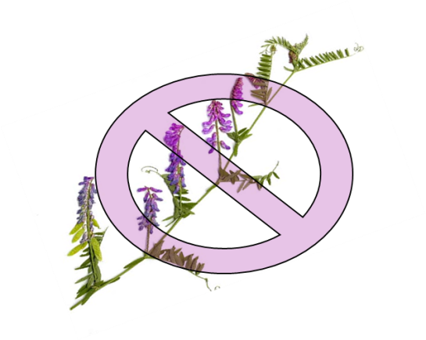
Vetch-Busters Registration Form

Your name: Click here to enter text.

Phone: Click here to enter text.

Email address: Click here to enter text.

Residence address:Click here to enter text.

Mailing address (if different):Click here to enter text.

Are you in a Service District? Yes:☐ No: ☐
Which one? (If not sure, we’ll figure it out):

A minimum of three to five neighbors is needed to get a Vetch-Busters group off the ground. Have you approached neighbors about joining a Vetch-Busters group in your neighborhood? Yes:☐ No: ☐

Have you found at least three neighbors who are interested? Yes:☐ No:☐

What do you think would be an appropriate “neighborhood” for your vetch-busters group? This has to do with where you live, how many neighbors want to be involved, how much vetch you already have, and how much work you and your neighbors are willing to put into this project. You can describe the neighborhood in words, draw a map on the back of this page, or attach a screen print from the Borough’s Property database website. If you aren’t sure what would be an appropriate neighborhood, we’ll help you determine it.

Tell us about your proposed “neighborhood”:Click here to enter text.

Every neighborhood group needs at least one person to organize it and get it rolling. Are you willing to be that person? This job would initially involve hosting a couple of meetings for interested neighbors and Fairbanks Cooperative Weed Management Association people. After the group was formed, other members could help with keeping the group rolling.
____________________________________________________________________________________

Please fill out this form and either:
Save the completed document and email it to: Fswcd.tech@gmail.com
Or print it and mail it to the Fairbanks Cooperative Weed Management Area, Attn: Darcy Etcheverry, 590 University Ave., Ste. 2, Fairbanks, AK 99709

Questions? Call Darcy Etcheverry at 479-1213, ext. 104, or Trish Wurtz at 451-2799

